SBDI-LA developer workshop, 09-10 June, 2022

**Duration:** Thursday 09 June 10:00 - Friday June 14:00

**Venue:** SMHI, Sven Källfelts gata 15, building 31, Nya Varvet, Västra Frölunda (Gothenburg)

**Participants:** Mathieu Blanchet (LU), Johan Bäckman (LU), Danilo Di Leo (LnU), Ingimar Erlingsson (NRM), Hans Höök (NRM), Martin Käck (SLU-Adb), Andreas Loo (SMHI), Daniel Lundin (LnU), Dave Martin (ALA), Maria Prager (SU/KI), Vicente J. Ruiz Jurado (LAC/GBIF.ES), Manash Shah (NRM), Lisa Sundqvist (SMHI).

**Organisations:** CSIRO-Atlas of Living Australia (ALA), GBIF Spain (GBIF.ES), Karolinska Institute (KI), Linnaeus University (LnU), Living Atlases community (LAC), Lund University (LU), Stockholm University (SU), Swedish Meteorological and Hydrological Institute (SMHI), Swedish Museum of Natural History (NRM), Swedish Species Information Centre (SLU-Adb)

**Travel info:** *From Landvetter Airport:* [Flygbussarna Airport Coach](https://www.flygbussarna.se/en/) departs from a stop just outside the arrival hall, and takes you to Gothenburg city center in 30 min. Public transport to SMHI typically involves numerous transfers (see [reseplaneraren](https://www.vasttrafik.se/reseplanering/reseplaneraren/) for details), unless you are willing to walk part of the distance. If so, walk to Brunnsparken stop B1, take the 11 tram towards Saltholmen, and get off at Nya Varvsallén. From there, walk ca. 1 km north to SMHI.

If you are going somewhere between 07:00-10:00 in the morning you can also take the 114 "Ö-snabben" bus from Brunnsparken directly to Örlogsvägen. Departure times from Brunnsparken to Örlogsvägen: 07.17, 07.56, 08.43, 09.18 and 09.54

*From Gothenburg Central station:* Take the 11 tram from Centralstationen stop D, and see above.

|  |  |
| --- | --- |

**Hotel:** [Dockyard Hotell](https://dockyardhotel.se) (Skeppet Ärans Väg 23, 426 71 Västra Frölunda).

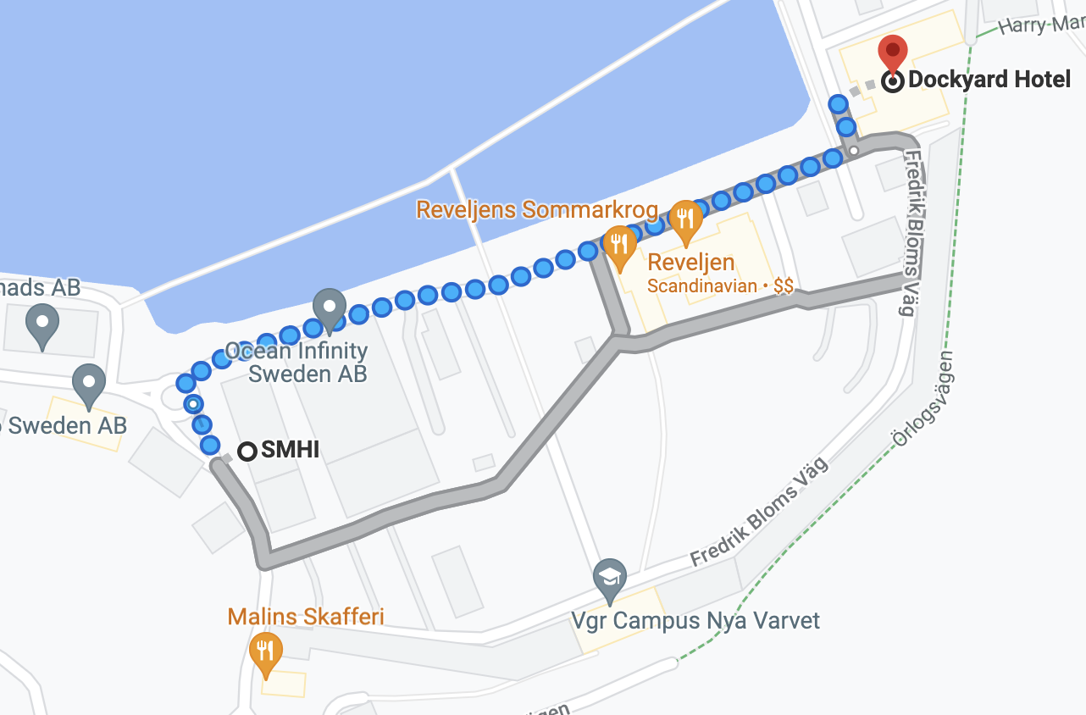

| **Day 1: Thursday 9 June** | |
| --- | --- |
| 10:00-10:15 | Welcome address, practical arrangements (Manash, Andreas) |
| 10:15-10:45 | Introduction to SBDI Deployment 2.0 (Manash, Hans) |
| 10:45-11:15 | Adaptation of existing LA modules (Biocollect, Ecodata, ZoaTrack...) for handling systematic monitoring, animal movement and sensor data (Mathieu) |
| 11:15-11:45 | A semi-integrated module for molecular data (ASV portal) and associated atlas adaptation (Maria). Lessons from successful collaboration on the nf-core/ampliseq bioinformatics pipeline (Daniel) |
| 11:45-13.00 | Lunch - [Malins Skafferi](https://www.malins-skafferi.se/) |
| 13:00-13:30 | Planned development and challenges of making automated image- and video-based data available  in SBDI (Andreas) |
| 13:30-14:00 | The Species Observation System (SOS) as part of the SBDI data flow infrastructure (Martin) |
| 14:00-14:45 | Brief overview of LA platform components and planned developments for these (Dave). Wish list:   * Pipelines (ingestion/indexing of new extensions, e.g. 'DNA derived data', and name-matching of non-Linnean placeholder names) * Sensitive data services * Experience of previous collaborations on other projects... * How can community members influence LA development?   (also possible to continue after coffee, and defer Discussion until the next day) |
| 14:45-15:00 | Coffee break |
| 15:00-15:45 | Overview of the LA organisation and development projects within this (Vicente) |
| 15:45-17:00 | Discussion (or some time for Dave and/or Vicente to extend their talks) |
| 18:30 | Dinner at [Brewers Beer Bar](https://brewersbeerbar.se/), Tredje Långgatan 8  (bus from directly outside the venue at 17:42 towards Järntorget) |
| **Day 2: Friday 10 June** | |
| 09.00–10:30 | Discussion aimed at formulating a practical framework for future collaboration - How do we facilitate and encourage new initiatives and collaboration within the community? Follow-up? (Everyone) |
| 10:30-10:45 | Coffee break |
| 10:45-11:45 | Continued discussion (Everyone) |
| 11:45-13.00 | Lunch - [Röda Sten](http://xn--rdasten-90a.se/) |
| 13:00-13:45 | Continued discussion (Everyone) |
| 13:45-14:00 | Concluding remarks (Manash) |

<https://www.gbif.org/event/33MQ8ZI9xuC98AekewiMr8/gbif-community-webinar-diversifying-the-gbif-data-model>